1. **Libraries**: No need to rewrite code, well written, well tested with high quality.
2. **Problem**: You need to know what version of a particular library you need then go out find that version library, download, & add to classpath.
3. **Solution**: Maven has centralized all of that work into its **dependency management system**.  
   It really reduces the complexity of your work and complexity of managing different libraries.
4. Let’s start out by taking a look at the pom.xml file
5. 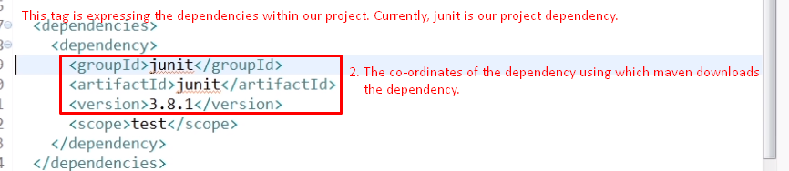
6. Let’s see the requirement before going for library.  
   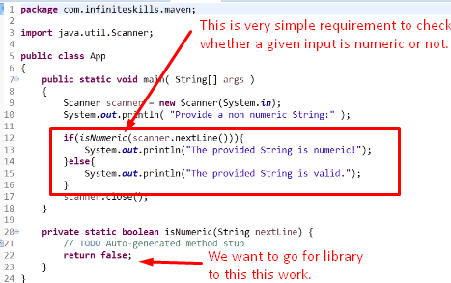*To do this work
7. 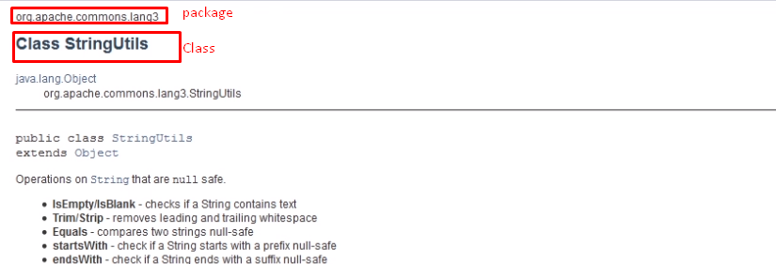
8. 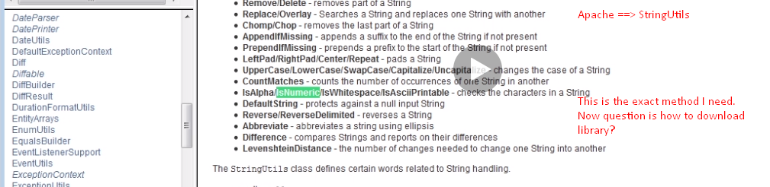
9. **Answer**: Go to **remote maven repos**. For this, we will use **maven central repo**.
10. 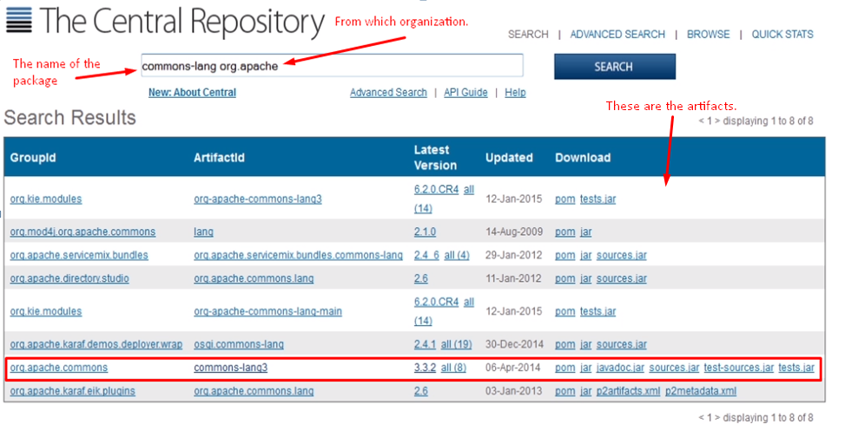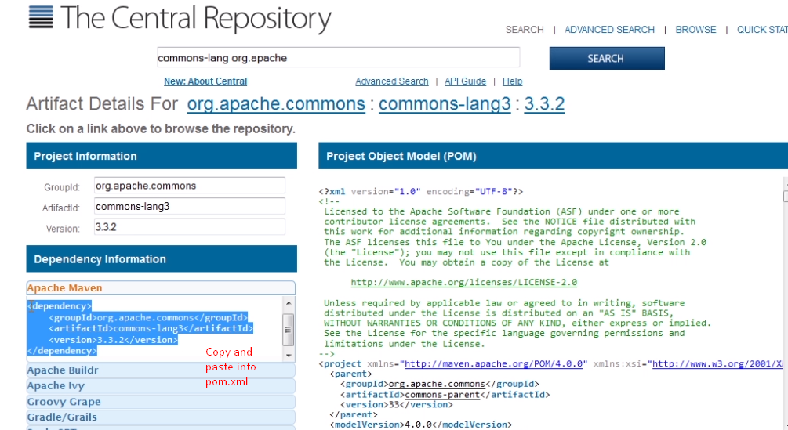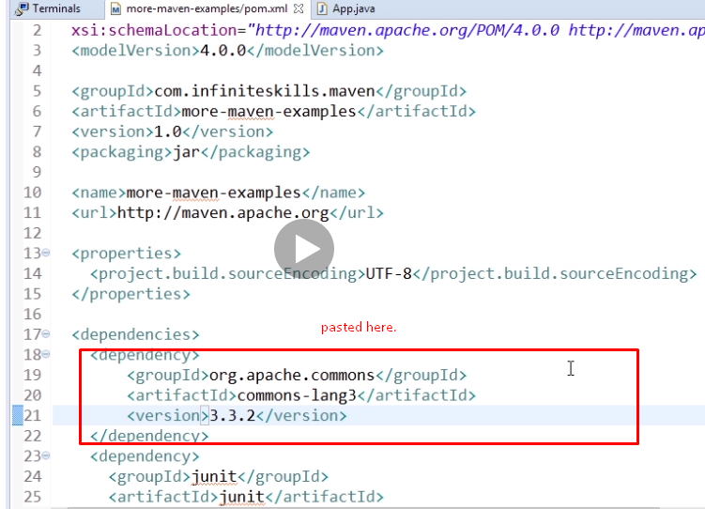
11. **command**: mvn dependency:copy-dependencies 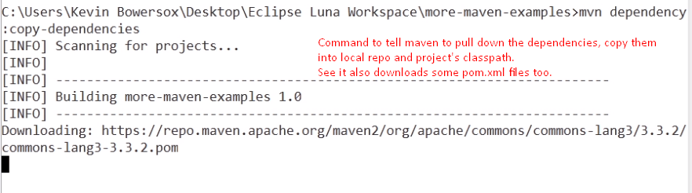

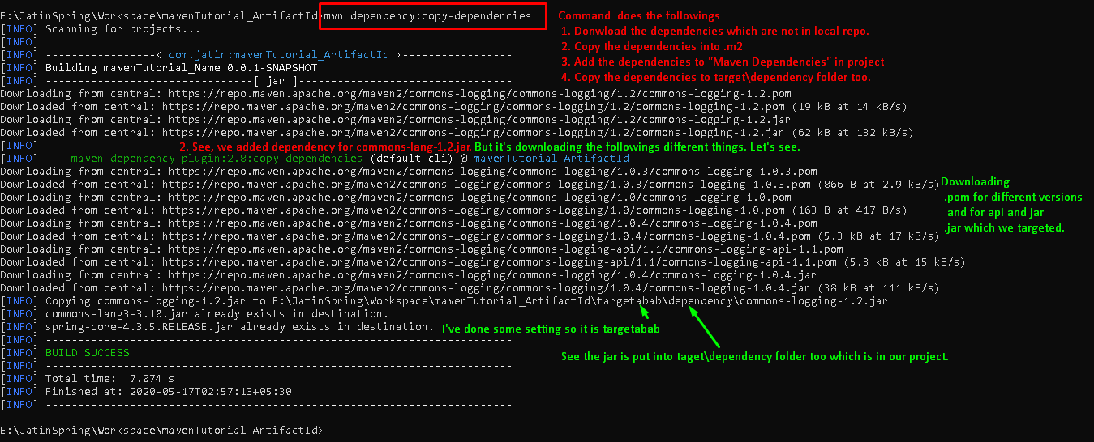

1. 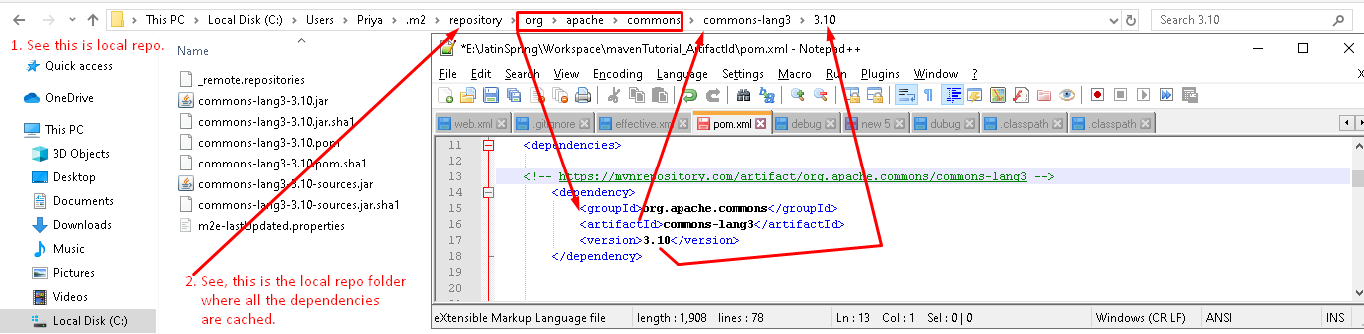
2. NOTE: You can also install your project as the above commons in your local repo.   
   Just run the **command** mvn install  
   